**DGME MIS GUIDELINES**

* First Connect your Internet to P&D network.

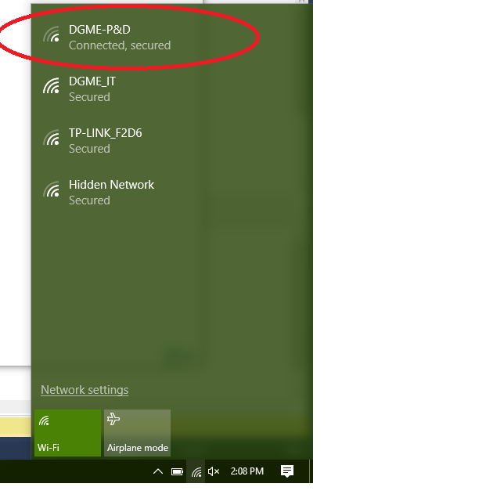

* Open Google or any search engine and type “mis.dgme.gov.pk:8080 ” or “192.168.5.2:8080 ”
* If you are registered then click on LOGIN, else register yourself first and contact IT-ADMINISTRATOR.

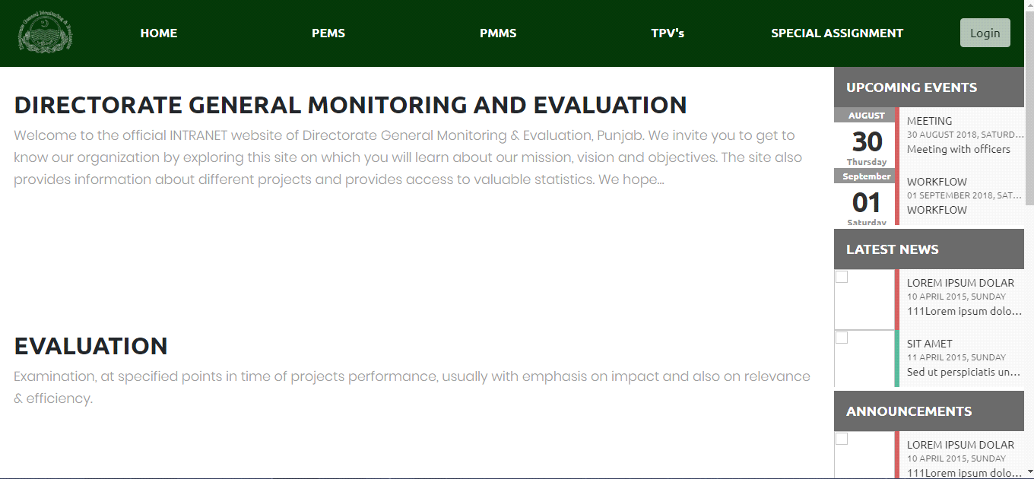

* Enter your username and password here. 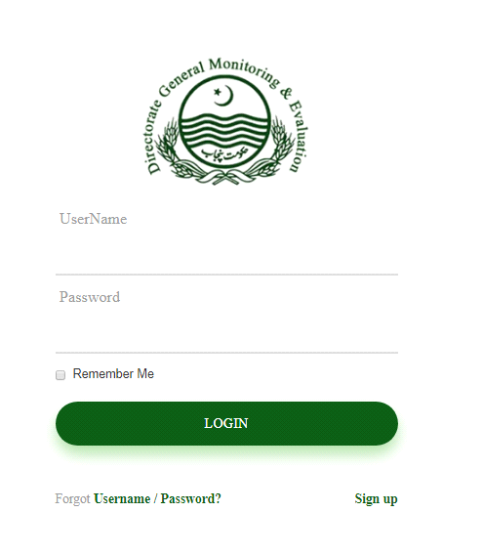
* After entering the required info, you will see your dashboards according to you roles.

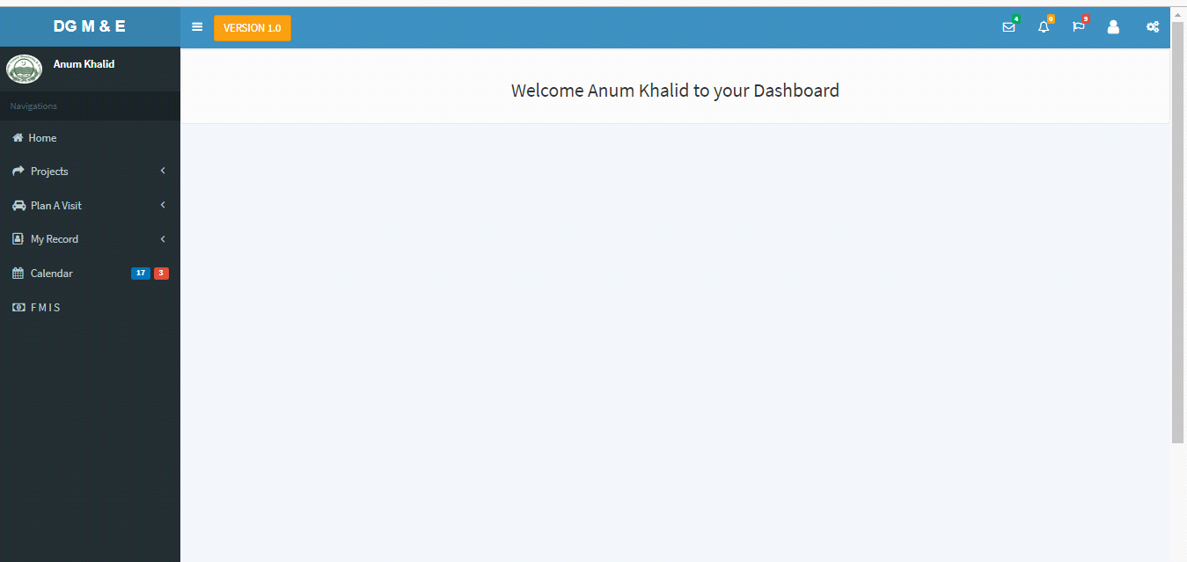

* By clicking on that user icon, you need to click reset your password first.

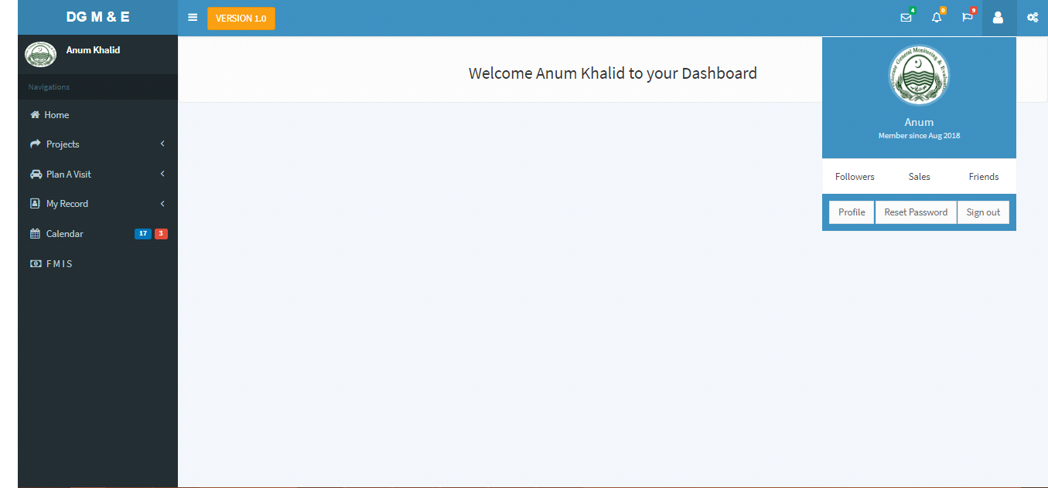

* Now enter your new password and confirm it by entering it again and save it.

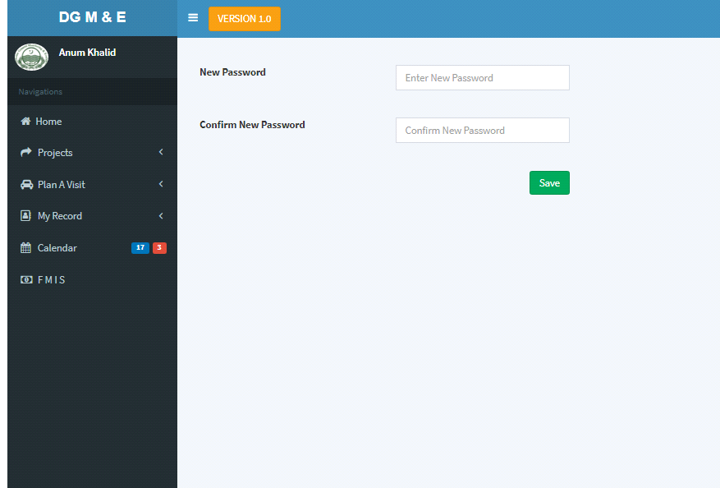

* To check your evaluation assignments you can click on

“projects”->“evaluation type”->“New Assignments ” or “In progress Assignments ” or “ Completed” on your left sidebar. 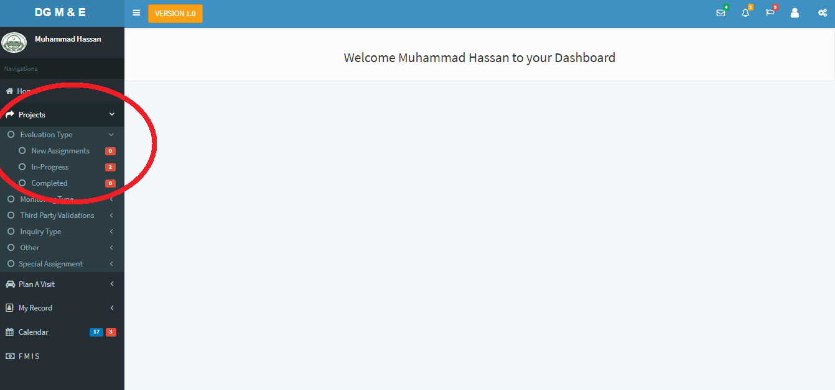

* Upon Clicking on “New Assignments”. You can check new Assignments assigned to you by Executives or Directors. 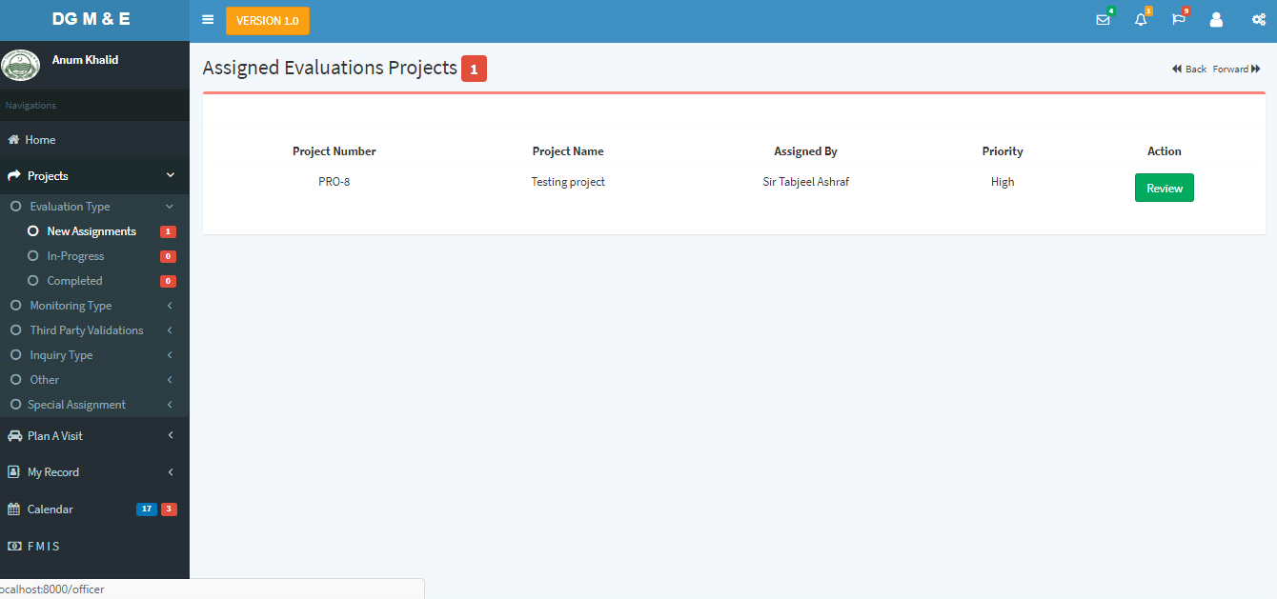
* Each officer need to review his/her new assigned tasks within 24hr. By clicking on review button officer need to check the requirments .
* if theres need to change something he/she should press “Edit” button and update the fields and save it within 24hrs,and if the pc4/form needs no changes then click on the. “Reviewed”button.

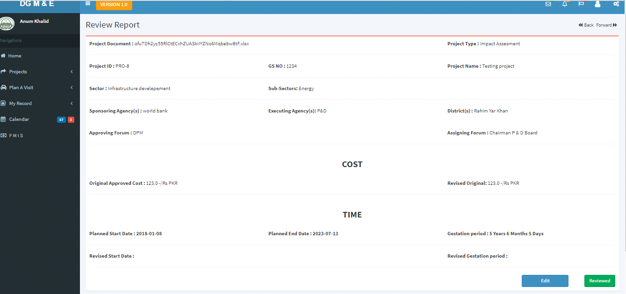

* Upon clicking reviewed or after saving the edited form ,the project will start appearing on you “Inprogress ” Tab.
* Officer can edit the project from inprogress tab too and can check the global progress of the projects.

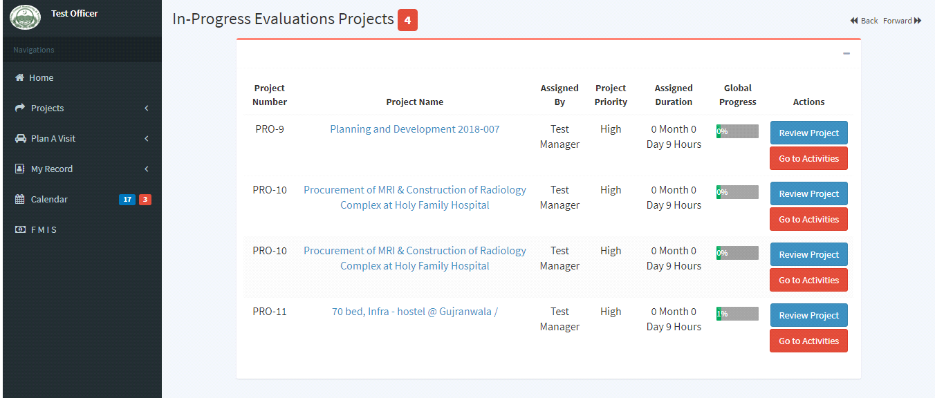

* From here you can see the activities assigned to you and update your progress accordingly.
* You can also chat with your higher authority in case you find any difficulty in any activity.

